**Parkside Lutheran Church**

*Rediscovering the Radical Love of Jesus*

*Gathering All*

*Serving All*

*Caring For All*



**May 4th, 2025**

**Third Sunday of Easter**

**Holy Communion 10:00am**

**Rev. Jeremiah Smith**

**Parkside Lutheran Values**

**Proclaiming Grace** - Jesus shared and lived out a message of grace, love, and new life. We believe these promises come from God freely, as a gift for all. We are loved and the Spirit inspires us to share this good news in accessible, relevant, and new ways. *Luke 4:17-19, John 1:16-17, John 3:16-17,* *Ephesians 2:8-9*

**Practicing Hospitality** – Jesus welcomed the little children, broke bread with outcasts, and proclaimed the Good News to all. Whether you are strong in faith, wrestling with doubt, or somewhere in between, we affirm that you are welcome here. Jesus is for everyone. *Leviticus 19:34, Matthew 9:10, Matthew 19:14, Hebrews 13:2*

**Loving Boldly** - Jesus challenged traditions to demonstrate God’s justice and love of neighbor. His compassionate and sacrificial love inspires us to take risks. Striving to follow his command to love neighbor, our ministries serve, transform, and advocate for folks near and far. *Micah 6:8,* *Mark 11:15-17, Luke 10:25-28, John 15:12-13*

**Cultivating Community** - Jesus built communities that transformed lives. We are the body of Christ and we are called to continue this ministry of transformation. Guided by the Holy Spirit, we build connections within and outside of these walls, and with all of God’s creation. *Ecclesiastes 4:9-12, Matthew 28:16-20, 1 Corinthians 12:12-14, Galatians 3:26-29*

**Welcome Visitors!**

**Please use QR code**

**to let us know you were here today or to sign up for our weekly enewsletter**

*or, sign up for weekly enewsletter via website parksidelutheran.org*.

Find us on Facebook & Instagram *WIFI: Balcony* password: FreeGrace

**For your safety in the event of an emergency:** In addition to the three exits in the back of the sanctuary, there are exits on either side of the altar (on left side: floor level near piano *and* up steps past altar. On right side: up steps to the altar, past band area)

***Contact us:*** (716) 836-1361

2 Wallace Ave. Buffalo, NY 14214

*parksidelutheran.org |* [*parksidelutheran@gmail.com*](mailto:parksidelutheran@gmail.com)

**GATHER***The Holy Spirit calls us together as the people of God.*

**Introduction to the Day:** *The disciples make a big splash and eat breakfast with the risen Jesus. Wading in the water (remembering baptism) and eating with Jesus (celebrating holy communion) is our weekly encounter with the risen Christ. Jesus asks us again and again: Do you love me? And Jesus invites us, again and again, to follow him, bringing the Easter life to others.*

**Prelude** Michael Hooker, *Music Director*

**Call to Worship** *Please stand as you are able*

WA: Siblings, if you lift your net and it is empty, come here!   
**C:** **We’ll cast it out again into Christ’s abundance.** WA:If you open your eyes but do not recognize the Holy One, come here! **C:** **We’ll find the Risen Christ here among us.** WA:If your life is filled with mourning, come here! **C:** **Christ is leading a dance of joy.** WA:Come here, sisters and brothers! **C:** **To give blessing and honor and glory to God!**

**+Gathering Hymn Christ is Alive! Let Christians Sing** **ELW #389**

*(printed next page)*

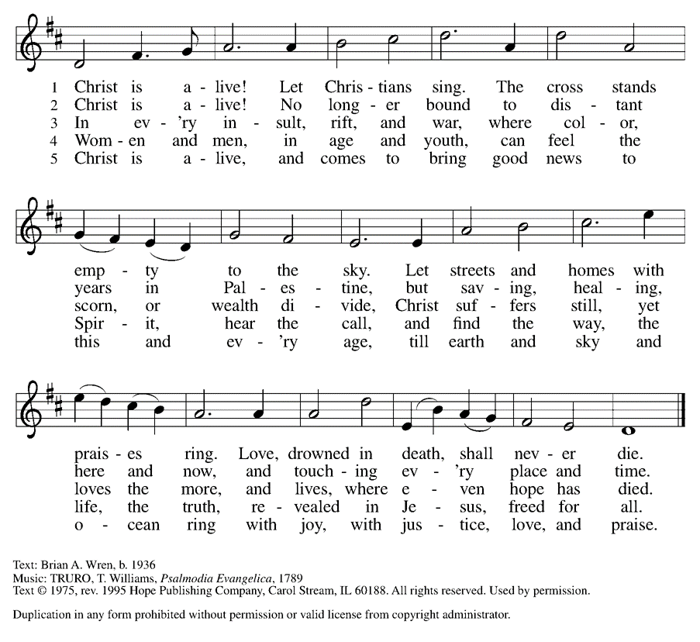

**Welcome and Announcements**

**Holy Baptism:** Westin Patrick Pizza *ELW p. 227*

**P:** God, who is rich in mercy and love, gives us a new birth into a living hope through the sacrament of baptism. By water and the Word God delivers us from sin and death and raises us to new life in Jesus Christ. We are united with all the baptized in the one body of Christ, anointed with the gift of the Holy Spirit, and joined in God's mission for the life of the world.

**P:** Who do you present to be baptized? **Sponsors**: We present Westin for baptism.

**P:** Called by the Holy Spirit, trusting in the grace and love of God, as his parents, do you desire to have Westin baptized into Christ? **Parents:** We do.

**P:** As you bring him to receive the gift of baptism, you are entrusted with responsibilities: to live with him among God's faithful people, bring him to the word of God and the holy supper, teach him the Lord's Prayer, the Creed, and the Ten Commandments, place in him hands the holy scriptures, and nurture him in faith and prayer, so that he may learn to trust God, proclaim Christ through word and deed, care for others and the world God made, and work for justice and peace.

**P**: Do you promise to help Westin grow in the Christian faith and life?

**Parents:** We do.

**P**: *Sponsors*, do you promise to nurture Westin in the Christian faith as you are empowered by God's Spirit, and to help him live in the covenant of baptism and in communion with the church? **Sponsors**: We do.

**P:** People of God, do you promise to support Westin and pray for him in his new life in Christ? **C: We do.**

**+ Profession of Faith**

**P:** All together as the people of God, I ask you to profess your faith in Christ Jesus, reject sin, and confess the faith of the church.

P: Do you renounce the devil and all the forces that defy God?

**C: We renounce them.**

P: Do you renounce the powers of this world that rebel against God?

**C: We renounce them.**

P: Do you renounce the ways of sin that draw you from God?

**C: We renounce them.**

P: Do you believe in God the Father?

**C: I believe in God, the Father almighty, creator of heaven and earth.**

P: Do you believe in Jesus Christ, the Son of God?

**C: I believe in Jesus Christ, God's only Son, our Lord, who was conceived by the Holy Spirit, born of the virgin Mary, suffered under Pontius Pilate, was crucified, died, and was buried; he descended to the dead.* On the third day he rose again; he ascended into heaven, he is seated at the right hand of the Father, and he will come to judge the living and the dead.**

P: Do you believe in God the Holy Spirit?

**C: I believe in the Holy Spirit, the holy catholic church, the communion of saints, the forgiveness of sins, the resurrection of the body, and the life everlasting.**

**Thanksgiving at the Font**

P: The Lord be with you. **C: And also with you.**

P: Let us give thanks to the Lord our God.

**C: It is right to give our thanks and praise.**

P: We give you thanks, O God, for in the beginning your Spirit moved over the waters and by your Word you created the world, calling forth life in which you took delight. Through the waters of the flood you delivered Noah and his family, and through the sea you led your people Israel from slavery into freedom.

At the river your Son was baptized by John and anointed with the Holy Spirit. By the baptism of Jesus' death and resurrection you set us free from the power of sin and death and raise us up to live in you.

Pour out your Holy Spirit, the power of your living Word, that those who are washed in the waters of baptism may be given new life. To you be given honor and praise through Jesus Christ our Lord, in the unity of the Holy Spirit, now and forever. **C: Amen.**

*The assembly may be seated.*

**Baptism**

P: Westin Patrick, I baptize you in the name of the Father, and of the Son, and of the Holy Spirit. **Amen.**

Let us pray. We give you thanks, O God, that through water and the Holy Spirit you give your daughters and sons new birth, cleanse them from sin, and raise them to eternal life.

*Laying both hands on the head of Westin the minister prays:*

P: Sustain Westin with the gift of your Holy Spirit: the spirit of wisdom and understanding, the spirit of counsel and might, the spirit of knowledge and the fear of the Lord, the spirit of joy in your presence, both now and forever. **Amen.**

Westin, child of God, you have been sealed by the Holy Spirit and marked with the cross of Christ forever. Amen.

**Welcome**

**WA**: Jesus said, I am the light of the world.

Whoever follows me will have the light of life.

**P**: Let us welcome Westin.

**C: We welcome you into the body of Christ and into the mission we share: join us in giving thanks and praise to God and bearing God's creative and redeeming word to all the world.**

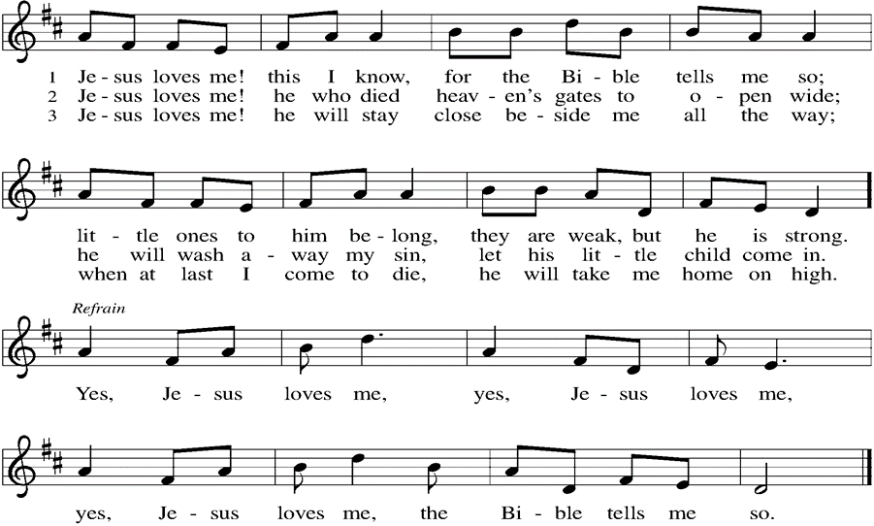

**Greeting**

WA:The grace of our Lord, Jesus Christ, the love of God, and the communion of the Holy Spirit be with you all. **C:** **And also with you.**

**Prayer of the Day**

WA: Let us pray together.

**C: Eternal and all-merciful God, with all the angels and all the saints we laud your majesty and might. By the resurrection of your Son, show yourself to us and inspire us to follow Jesus Christ, our Savior and Lord, who lives and reigns with you and the Holy Spirit, one God, now and forever. Amen.**

**WORD**

*God speaks to us in scripture readings, preaching and song.*

**First Reading: Acts 9:1-20**

Saul (later called Paul) was an ardent persecutor of all who followed the Way of Christ. This reading recounts the story of his transformation beginning with an encounter with Jesus Christ on the way to Damascus.

L: 1 Saul, still breathing threats and murder against the disciples of the Lord, went to the high priest 2 and asked him for letters to the synagogues at Damascus, so that if he found any who belonged to the Way, men or women, he might bring them bound to Jerusalem. 3 Now as he was going along and approaching Damascus, suddenly a light from heaven flashed around him. 4 He fell to the ground and heard a voice saying to him, “Saul, Saul, why do you persecute me?” 5 He asked, “Who are you, Lord?” The reply came, “I am Jesus, whom you are persecuting. 6 But get up and enter the city, and you will be told what you are to do.” 7 The men who were traveling with him stood speechless because they heard the voice but saw no one. 8 Saul got up from the ground, and though his eyes were open, he could see nothing; so they led him by the hand and brought him into Damascus. 9 For three days he was without sight and neither ate nor drank.  
  10 Now there was a disciple in Damascus named Ananias. The Lord said to him in a vision, “Ananias.” He answered, “Here I am, Lord.” 11 The Lord said to him, “Get up and go to the street called Straight, and at the house of Judas look for a man of Tarsus named Saul. At this moment he is praying, 12 and he has seen in a vision a man named Ananias come in and lay his hands on him so that he might regain his sight.” 13 But Ananias answered, “Lord, I have heard from many about this man, how much evil he has done to your saints in Jerusalem, 14 and here he has authority from the chief priests to bind all who invoke your name.” 15 But the Lord said to him, “Go, for he is an instrument whom I have chosen to bring my name before gentiles and kings and before the people of Israel; 16 I myself will show him how much he must suffer for the sake of my name.” 17 So Ananias went and entered the house. He laid his hands on Saul and said, “Brother Saul, the Lord Jesus, who appeared to you on your way here, has sent me so that you may regain your sight and be filled with the Holy Spirit.” 18 And immediately something like scales fell from his eyes, and his sight was restored. Then he got up and was baptized, 19 and after taking some food, he regained his strength.   
  For several days he was with the disciples in Damascus, 20 and immediately he began to proclaim Jesus in the synagogues, saying, “He is the Son of God.” L: Word of God, word of life. **C: Thanks be to God.**

**Psalm: Psalm 30** *You have turned my wailing into dancing.* (Ps. 30:11)

L:  1I will exalt you, O Lord, because you have lifted me up  
  and have not let my enemies triumph over me.  
**C:** 2 **O Lord my God, I cried out to you, and you restored me to health.**

L: 3 You brought me up, O Lord, from the dead;  
  you restored my life as I was going down to the grave.  
**C:** 4 **Sing praise to the Lord, all you faithful;**

**give thanks in holy remembrance.**    
L: 5 God’s wrath is short; God’s favor lasts a lifetime.  
  Weeping spends the night, but joy comes in the morning.  
**C:** 6 **While I felt secure, I said, “I shall never be disturbed.**  
L: 7 You, Lord, with your favor, made me as strong as the mountains.”  
  Then you hid your face, and I was filled with fear.  
**C:** 8 **I cried to you, O Lord;** **I pleaded with my Lord, saying,**  
L: 9 “What profit is there in my blood, if I go down to the pit?  
  Will the dust praise you or declare your faithfulness?  
**C:** 10 **Hear, O Lord, and have mercy upon me; O Lord, be my helper.”**   
L: 11 You have turned my wailing into dancing;  
   you have put off my sackcloth and clothed me with joy.  
**C:** 12 **Therefore my heart sings to you without ceasing;**  
  **O Lord my God, I will give you thanks forever.**

L: Word of God, word of life. **C: Thanks be to God.**

**Second Reading: Revelation 5:11-14**

The vision of John recorded in Revelation offers a glimpse of cosmic worship around the throne. At its center is “the Lamb who was slain.”

11 Then I looked, and I heard the voice of many angels surrounding the throne and the living creatures and the elders; they numbered myriads of myriads and thousands of thousands, 12 singing with full voice,   
 “Worthy is the Lamb that was slaughtered to receive power and wealth and wisdom and might and honor and glory and blessing!”  
13 Then I heard every creature in heaven and on earth and under the earth and in the sea and all that is in them, singing,   
 “To the one seated on the throne and to the Lamb be blessing and honor and glory and might forever and ever!”  
14 And the four living creatures said, “Amen!” And the elders fell down and worshiped.

L: Word of God, word of life. **C: Thanks be to God.**

### *Please stand as you are able*

### **+Gospel Acclamation** **Halle, Halle, Hallelujah** **ELW #172**

### *(printed next page)*

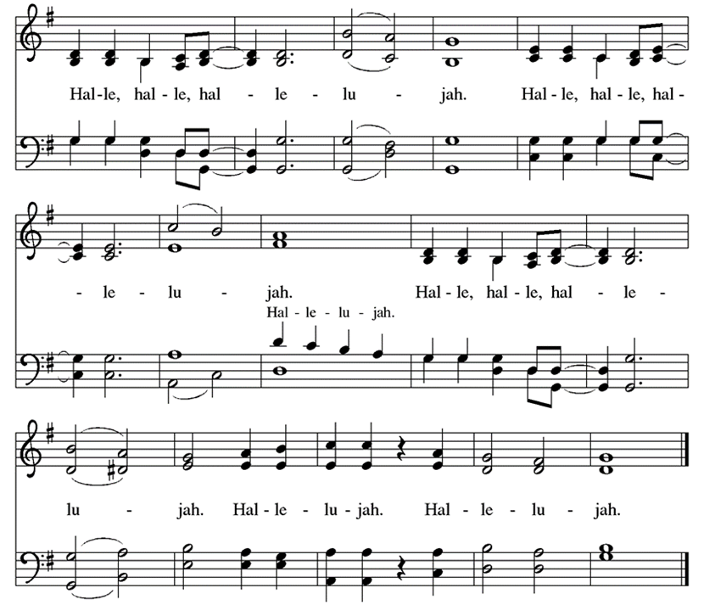

**Gospel Reading: John 21:1-19**

The risen Christ appears again to his disciples by the sea where they were first called. After echoes of the fishing and feeding miracles, he gives a final reminder of the cost of a disciple’s love and obedience. P: The Holy Gospel According to John. **C: Glory to you, O Lord.**

P:  1 After [he appeared to his followers in Jerusalem,] Jesus showed himself again to the disciples by the Sea of Tiberias, and he showed himself in this way. 2 Gathered there together were Simon Peter, Thomas called the Twin, Nathanael of Cana in Galilee, the sons of Zebedee, and two others of his disciples. 3 Simon Peter said to them, “I am going fishing.” They said to him, “We will go with you.” They went out and got into the boat, but that night they caught nothing.  
  4 Just after daybreak, Jesus stood on the beach, but the disciples did not know that it was Jesus. 5 Jesus said to them, “Children, you have no fish, have you?” They answered him, “No.” 6 He said to them, “Cast the net to the right side of the boat, and you will find some.” So they cast it, and now they were not able to haul it in because there were so many fish. 7 That disciple whom Jesus loved said to Peter, “It is the Lord!” When Simon Peter heard that it was the Lord, he put on his outer garment, for he had taken it off, and jumped into the sea. 8 But the other disciples came in the boat, dragging the net full of fish, for they were not far from the land, only about a hundred yards off.  
  9 When they had gone ashore, they saw a charcoal fire there, with fish on it, and bread. 10 Jesus said to them, “Bring some of the fish that you have just caught.” 11 So Simon Peter went aboard and hauled the net ashore, full of large fish, a hundred fifty-three of them, and though there were so many, the net was not torn. 12 Jesus said to them, “Come and have breakfast.” Now none of the disciples dared to ask him, “Who are you?” because they knew it was the Lord. 13 Jesus came and took the bread and gave it to them and did the same with the fish. 14 This was now the third time that Jesus appeared to the disciples after he was raised from the dead.  
  15 When they had finished breakfast, Jesus said to Simon Peter, “Simon son of John, do you love me more than these?” He said to him, “Yes, Lord; you know that I love you.” Jesus said to him, “Feed my lambs.” 16 A second time he said to him, “Simon son of John, do you love me?” He said to him, “Yes, Lord; you know that I love you.” Jesus said to him, “Tend my sheep.” 17 He said to him the third time, “Simon son of John, do you love me?” Peter felt hurt because he said to him the third time, “Do you love me?” And he said to him, “Lord, you know everything; you know that I love you.” Jesus said to him, “Feed my sheep. 18 Very truly, I tell you, when you were younger, you used to fasten your own belt and to go wherever you wished. But when you grow old, you will stretch out your hands, and someone else will fasten a belt around you and take you where you do not wish to go.” 19 (He said this to indicate the kind of death by which he would glorify God.) After this he said to him, “Follow me.”

P: The Gospel of the Lord. **C: Praise to you, O Christ.**

**Sermon** Rev. Jeremiah Smith

*Please stand as you are able.*

**Hymn of the Day: The Church of Christ in Every Age ELW #729**

*(printed next page)*

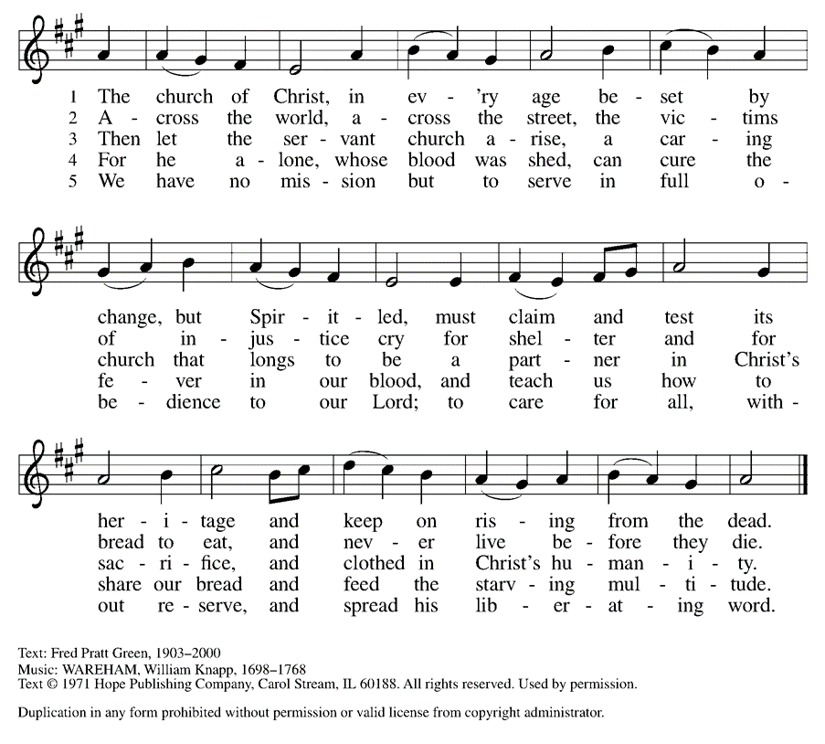

**Prayers of the People**  
WA: God of resurrection and new life, we come before you in prayer for the church, the world, and all who are in need. *(a brief silence)*

WA: Your love sustains the church and its ministries. By that love, equip youth directors, Sunday school teachers, and all who guide formation in the church to nurture vibrant, living faith among your people. Hear us, O God.

**C: Your mercy is great.**

WA: Your wisdom guides all who strive for justice and peace. Strengthen the work of grassroots organizers, especially among communities on the frontlines of justice work. Amplify the voices of those most in need, that their leadership guides the way forward. Hear us, O God. **C: Your mercy is great.**

WA: Your compassion surrounds all who are in need. We pray for all people experiencing poverty and food insecurity, and for all struggling with debt and economic uncertainty. Reassure all who experience hopelessness or need your tender care, especially those we name aloud or in the silence of our hearts. Hear us, O God. **C: Your mercy is great.**

WA: You invite all people to your table of grace. Make this a community of radical hospitality where all feel loved and celebrated. Show us how to better welcome visitors and bless the ministries of hospitality in this place. Hear us, O God. **C: Your mercy is great.**

WA: We praise you for the witness of your saints of all times and places (especially Monica, mother of Augustine). May their lives of faith guide us in our own journeys with you, today and every day. Hear us, O God.

**C: Your mercy is great.**

WA: We commend these and all our prayers to you, O God, trusting that you are always with us; in the name of Jesus Christ, our risen Savior. **C:** **Amen.**

**Peace**

P: The peace of Christ be with you always. **C: And also with you.**

**Meal**

*God feeds us with the presence of Jesus Christ*

**Offering** *Congregation may be seated*

We are grateful to those who help sustain our mission. To donate online, please use QR code:



**Offering Prayer**

WA: Let us pray together:

**C: Risen One, you have gathered us around your table of grace along with these gifts we bring. Come among us again, breathe your life into us, and enliven us with this meal, that we may live as your risen body in the world. Amen.**

*Please stand as you are able*

***+* Offertory Song “**Praise God From Whom….” *(doxology)*

ELW 885 (*music from ELW 883*)

***Praise God, from whom all blessings flow;***

***praise God, all creatures here below;***

***praise God above, ye heav’nly host;***

***praise Father, Son, and Holy Ghost. Amen.***

**GREAT THANKSGIVING**

P: The Lord be with you. **C: And also with you.**

P: Lift up your hearts. **C: We lift them to the Lord.**

P: Let us give thanks to the Lord our God.

**C: It is right to give our thanks and praise.**

**Preface:**

P: It is indeed right, our duty and our joy, that we should at all times and in all places give thanks and praise to you, almighty and merciful God for the glorious resurrection of our Savior Jesus Christ, the true Paschal Lamb who gave himself to take way our sin, who in dying has destroyed death, and in rising has brought us to eternal life. And so, with Mary Magdalene and Peter and all the witnesses of the resurrection, with earth and sea and all their creatures, and with angels and archangels, cherubim and seraphim, we praise your name and join their unending hymn:

**Holy Holy Holy ELw** setting 4

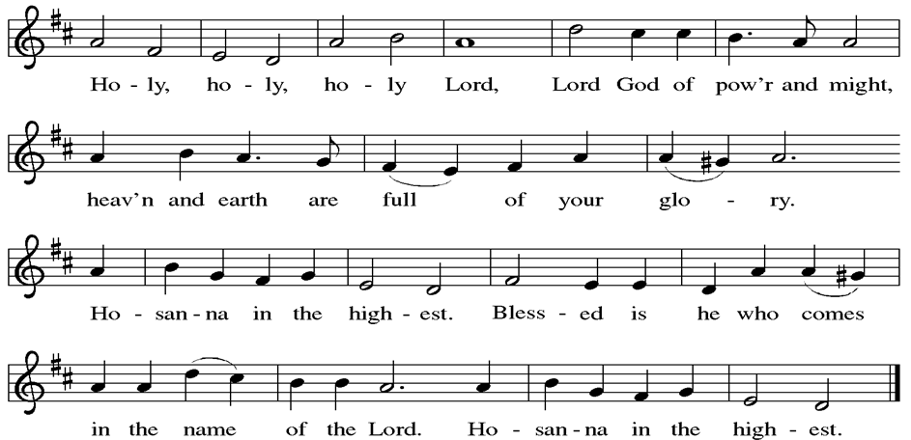

**Thanksgiving at the Table**

P: Blessed are you, O God of the universe. Your mercy is everlasting and your faithfulness endures from age to age.

Praise to you for creating the heavens and the earth. Praise to you for saving the earth from the waters of the flood. Praise to you for bringing the Israelites safely through the sea. Praise to you for leading your people through the wilderness to the land of milk and honey. Praise to you for the words and deeds of Jesus, your anointed one. Praise to you for the death and resurrection of Christ. Praise to you for your Spirit poured out on all nations.

In the night in which he was betrayed, our Lord Jesus took bread, and gave thanks; broke it, and gave it to his disciples, saying: Take and eat; this is my body, given for you. Do this for the remembrance of me. Again, after supper, he took the cup, gave thanks, and gave it for all to drink, saying: This cup is the new covenant in my blood, shed for you and for all people for the forgiveness of sin.

Do this for the remembrance of me.

With this bread and cup we remember our Lord’s passover from death to life

as we proclaim the mystery of faith:

**C: Christ has died. Christ is risen. Christ will come again.**

P: O God of resurrection and new life: Pour out your Holy Spirit on us

and on these gifts of bread and wine. Bless this feast. Grace our table with your presence.

**C: Come, Holy Spirit.**

P: Reveal yourself to us in the breaking of the bread. Raise us up as the body of Christ for the world. Breathe new life into us. Send us forth, burning with justice, peace, and love.

**C: Come, Holy Spirit.**

P: With your holy ones of all times and places, with the earth and all its creatures, with sun and moon and stars, we praise you, O God, blessed and holy Trinity, now and forever. C: **Amen.**

**Lord’s Prayer**

P:Lord, remember us in your kingdom and teach us to pray.

**C: Our Father, who art in heaven, hallowed be thy name, thy kingdom come, thy will be done, on earth as it is in heaven. Give us this day our daily bread; and forgive us our trespasses, as we forgive those who trespass against us; and lead us not into temptation, but deliver us from evil. For thine is the kingdom, and the power, and the glory, forever and ever. Amen.**

**Invitation to the Table**

*At Parkside Lutheran Church we have an open table. We believe the invitation to receive comes from Jesus himself and all are welcome at Christ’s table. More than just Bread and Wine these are tangible signs of God’s love for you! If you do not wish to receive communion but would like a blessing, come forward and cross your arms over your chest. The Pastor will give you a blessing before you return to your seat via the side aisle. You’ll receive communion bread* in your hands and a small cup containing white wine or grape juice. When giving the bread and cup, the communion ministers say:*

*“*The body of Christ, given for you. The blood of Christ, shed for you.” *and each person may respond :* Amen *Please let Pastor know if you need gluten-free bread

P: Come to the table of grace. Receive the gift of new life.

**The Communion Distribution**

**Communion Song** ELWsetting 4

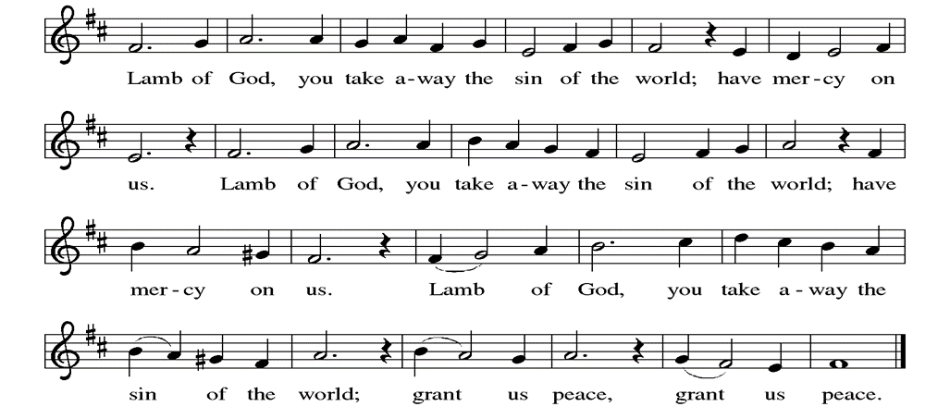

**Communion Song: Shine, Jesus, Shine**

**Lord, the light of your love is shining**

**in the midst of the darkness shining.**

**Jesus, Light of the world, shine upon us,**

**set us free by the truth You now bring us,**

**Shine on me, shine on me**

***Refrain:* Shine, Jesus, shine fill this land with the Father’s glory;**

**Blaze, Spirit, blaze, set our hearts on fire.**

**Flow, river, flow, flood the nations with grace and mercy;**

**Send forth Your word, Lord, and let there be light.**

**As we gaze on Your kingly brightness,**

**so our faces display Your likeness,**

**Ever changing from glory to glory,**

**mirror’d here may our lives tell Your story,**

**Shine on me, shine on me*. Refrain***

**Communion Song: Sanctuary**

*(printed next page)*

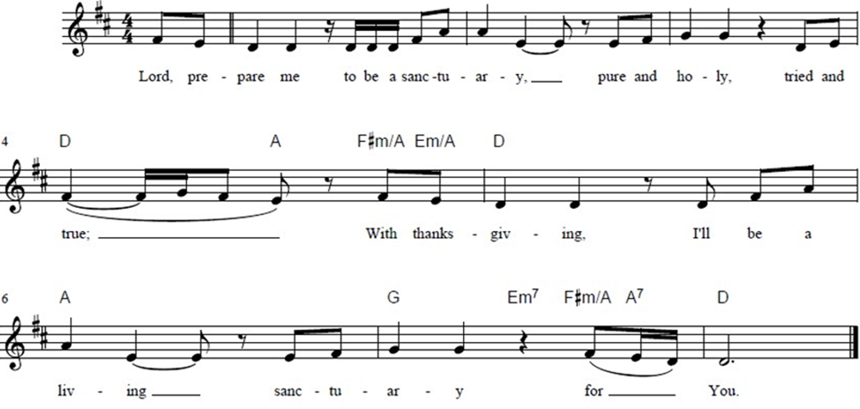

**Post Communion Blessing**

P: The Body and Blood of our Lord and Savior, Jesus Christ, strengthen you and keep you in God's grace. **C: Amen.**

**Prayer After Communion**

WA: Let us pray together.

**C: Living One, in this feast you have made yourself known to us. Send us now to tell of your wonders, sing of your glory, and proclaim your risen life to a wounded and weary world. Amen.**

**Sending -** *God blesses us and sends us in mission to the world.*

**Blessing**

P: The triune God, who was, who is, and who is to come, Sovereign, ☩Savior, and Spirit, light your way with resurrection dawn, now and always. **C: Amen.**

**Sending Hymn: Alleluia! Sing to Jesus ELW #392**

**(***printed next page)*

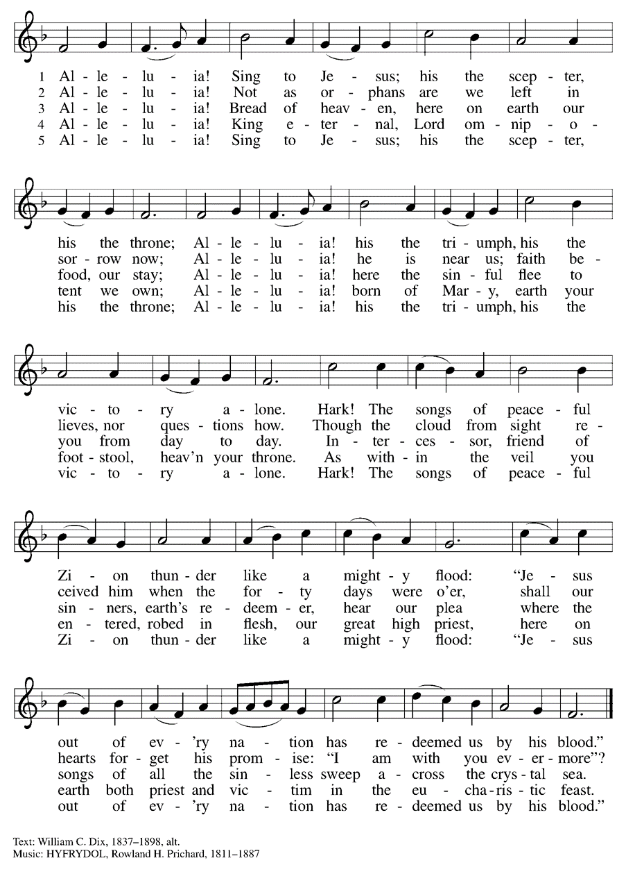

**Dismissal and Postlude**

WA: Parkside Lutheran Church is rediscovering the radical love of Jesus.

**C: Gathering All. Serving All. Caring for All.**

WA: Go in peace. In Christ you are made new. Alleluia! Alleluia!

**C: Thanks be to God. Alleluia! Alleluia!**

*ELW Music licensed from Sundays & Seasons, Augsburg Fortress CCLI MUSIC License # 11440069 , CCLI*

*Streaming License#21835523 Do not duplicate any music or Liturgy herein without license and permission*

*To sponsor Altar flowers or a Soloist in honor of a loved one*

*or to mark a special occasion. Contact the office for more info.*

**PARKSIDE STAFF:**

• The Rev.  Jeremiah Smith: prjeremiahpsmith@gmail.com

• Kris Pope & Suzanne Gracie, Admin. Assistants (Church Office): parksidelutheran@gmail.com

• Mike Hooker, Music Director: [mrhooker@me.com](mailto:mrhooker@me.com)

CHURCH OFFICE HOURS: M/T/R 10:00am-3:00pm   (716)836-1361

**SCHEDULES and Events**

Acolytes:

|  |  |  |  |
| --- | --- | --- | --- |
| 5/4/25 | Franklin | Max P | Kaiden |

Ushers:

|  |  |  |  |  |
| --- | --- | --- | --- | --- |
| **May 4** | Jean C. | Shannon | Rickey | David H. |
| **May 11 (Mom’s Day)** | Dave C. | Charlie R. | Dave C. | Tom S. |
| **May 18** | Sue S. | Marlene U. | David H. | Jeziah |
| **May 25 (Day Before Mem Day)** | Tom S. | Shannon | Rickey | Jean C. |

Worship Assistants

|  |  |  |  |  |
| --- | --- | --- | --- | --- |
| **May 4** | ONDA | KATHIE | TOM S | JAMES |
| **May 11** | JOHN | DAVE. P. | SUE S | MIKE M |

**Coming up:** *contact office for more info –* [*parksidelutheran@gmail.com*](mailto:parksidelutheran@gmail.com), *(716)836-1361*

* **Weekly Bible Study** w/ Pastor Jeremiah after Sunday worship - resumes May 4th
* May 7th – 6:30pm - Choir Practice
* May 21st 7 – 8pm – Brewing Theology at Steel Leaf Brewing Company
* June 1st Pride Parade
* June 8th Acolyte and Communion Assistant Training after worship
* June 15th Confirmation Sunday
* June 29th Pride Sunday
* Mon, June 30th SAVE THE DATE: Lutheran Charities 27th Annual Golf Classic

at Pendleton Creek Golf Club visit [www.wnylutherancharities.org](http://www.wnylutherancharities.org) for details

Detailed announcements and more are found in the e-newsletter (sent every Thursday). Check your promotions & spam tabs & drag to your Inbox or whitelist them so you don’t miss your weekly news! Sign up for e-newsletter on website **parksidelutheran.org** (at bottom of webpage) or sign up via constant contact with the QR code below.



**DID YOU KNOW?** Soon we will be mounting TVs in the sanctuary and no longer printing paper bulletins. **You can find the bulletin on our website** [**www.parksidelutheran.org**](http://www.parksidelutheran.org)*(and there is a link to the bulletin in the weekly e-newsletter to the Bulletin page)*. You can download to print it from home or view it on your phone/tablet. The bulletin is found on the “Worship” section of the website, under “Bulletin”, in the “DOWNLOADS” section.