**Parkside Lutheran Church**

*Rediscovering the Radical Love of Jesus*

*Gathering All*

*Serving All*

*Caring For All*



**September 21st, 2025**

**Time after Pentecost**

**Holy Communion 10:00am**

**Rev. Jeremiah Smith**

**Parkside Lutheran Values**

**Proclaiming Grace** - Jesus shared and lived out a message of grace, love, and new life. We believe these promises come from God freely, as a gift for all. We are loved and the Spirit inspires us to share this good news in accessible, relevant, and new ways. *Luke 4:17-19, John 1:16-17, John 3:16-17,* *Ephesians 2:8-9*

**Practicing Hospitality** – Jesus welcomed the little children, broke bread with outcasts, and proclaimed the Good News to all. Whether you are strong in faith, wrestling with doubt, or somewhere in between, we affirm that you are welcome here. Jesus is for everyone. *Leviticus 19:34, Matthew 9:10, Matthew 19:14, Hebrews 13:2*

**Loving Boldly** - Jesus challenged traditions to demonstrate God’s justice and love of neighbor. His compassionate and sacrificial love inspires us to take risks. Striving to follow his command to love neighbor, our ministries serve, transform, and advocate for folks near and far. *Micah 6:8,* *Mark 11:15-17, Luke 10:25-28, John 15:12-13*

**Cultivating Community** - Jesus built communities that transformed lives. We are the body of Christ and we are called to continue this ministry of transformation. Guided by the Holy Spirit, we build connections within and outside of these walls, and with all of God’s creation. *Ecclesiastes 4:9-12, Matthew 28:16-20, 1 Corinthians 12:12-14, Galatians 3:26-29*

**Welcome Visitors!**

**Please use QR code**

**to let us know you were here today or to sign up for our weekly enewsletter**

*or, sign up for weekly enewsletter via website parksidelutheran.org*.

Find us on Facebook & Instagram *WIFI: Balcony* password: FreeGrace

**For your safety in the event of an emergency:** In addition to the three exits in the back of the sanctuary, there are exits on either side of the altar (on left side: floor level near piano *and* up steps past altar. On right side: up steps to the altar, past band area)

***Contact us:*** (716) 836-1361

2 Wallace Ave. Buffalo, NY 14214

*parksidelutheran.org |* [*parksidelutheran@gmail.com*](mailto:parksidelutheran@gmail.com)

**GATHER***The Holy Spirit calls us together as the people of God.*

**Introduction to the Day:** *As we are invited today to consider what it means to be managers (rather than owners) of all that we have, it is crucial to recognize that we are bought with a price. “Christ Jesus, himself human…gave himself a ransom for all.” Apart from the generosity of God we have nothing—we are nothing. By God’s gracious favor we have everything we need.*

**Prelude** Michael Hooker, *Music Director*

**Call to Worship** *Please stand as you are able*

WA: King of all the earth, Creator of the universe, Holy Triune God, from everlasting to everlasting, you are Lord. We will give thanks to you, O Lord, with our whole hearts, for your glory is above the heavens;

**C: From the rising of the sun to it setting, we will praise the name of the Lord!**

WA: You raise the poor from the dust and lift the needy from the ash heap, transforming them with glory and honor;

**C: From the rising of the sun to it setting, we will praise the name of the Lord!**

WA: You bring fruitfulness from barrenness and give homes to the solitary;

**C: From the rising of the sun to it setting, we will praise the name of the Lord!**

WA: Who is like our God, the One who looks down from the heights on the heavens and the earth?

**C: From the rising of the sun to it setting, we will praise the name of the Lord!**

WA: This is our God, the Holy One.

**C: Come before him with thanksgiving and offer him the sacrifice of praise.**

**Gathering Hymn: Son of God, Eternal Savior ELW #655**

*(printed next page)*

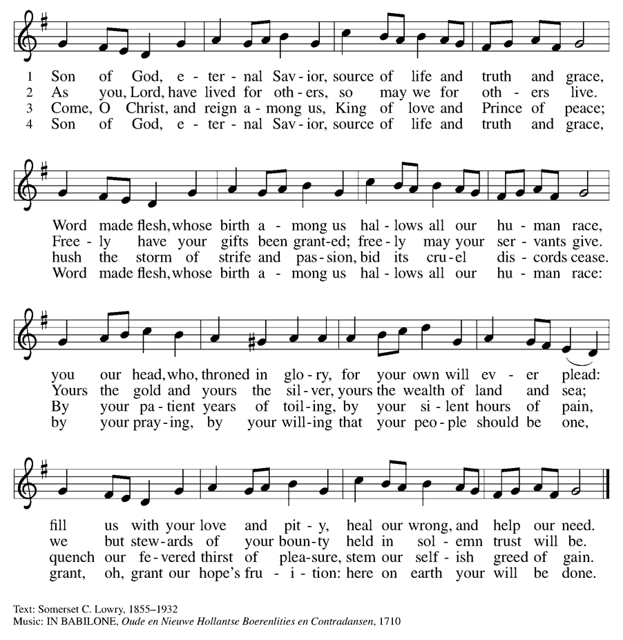

**Welcome and Announcements**

*Please stand as you are able.*

**+Confession and Forgiveness**

P: Blessed be the Holy Trinity, **+** one God, our maker, our helper and our keeper

**C: Amen.**

P: Trusting in God’s mercy, let us confess our sin in the presence of God and of one another. *(a brief silence)*  
P: Merciful and loving God,   
**C: we are your stiff-necked people. We trample on the needy. We grumble about your grace to others. We turn away from the poor. Have mercy on us and forgive our sins. Rejoice over us as ones who were lost and have been found. Amen.**

P: Even when we are faithless, God remains faithful. Jesus Christ came into the world to save sinners. You who were lost have been found. In the name of **+**Jesus, your sins are forgiven!

**C: Amen**

**Greeting**

WA:The grace of our Lord, Jesus Christ, the love of God, and the communion of the Holy Spirit be with you all. **C:** **And also with you.**

**Kyrie** setting 8

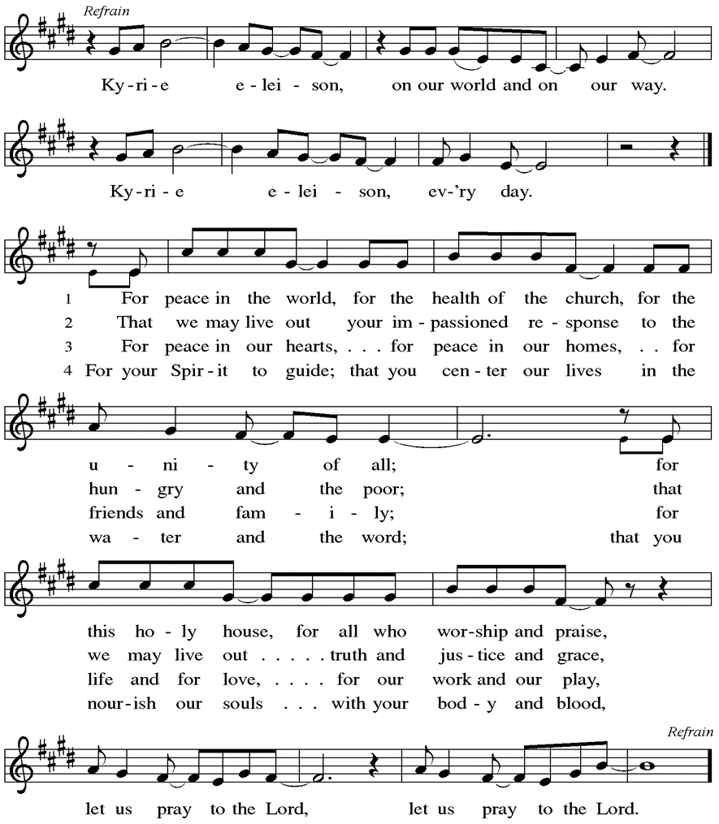

Words & music by Rick Founds, ©1989, Maranatha Praise, Inc., admin. Music Services.

**Prayer of the Day**

WA: Let us pray together.

**C: God among us, we gather in the name of your Son to learn love for one another. Keep our feet from evil paths. Turn our minds to your wisdom and our hearts to the grace revealed in your Son, Jesus Christ, our Savior and Lord. Amen.**

**Children’s Sermon:** *Jesus said, “Let the little children come to me!”*

*We welcome children in worship.*

**WORD**

*God speaks to us in scripture readings, preaching and song.*

**First Reading: Amos 8:4-7**

Amos was called by God to prophesy in the Northern Kingdom of Israel. Peace and prosperity in Israel led to corrupt business practices and oppression of the poor. The prophet declares that God will not tolerate such a situation.

L: 4Hear this, you who trample on the needy, and bring to ruin the poor of the land, 5 saying, “When will the new moon be over so that we may sell grain, and the Sabbath, so that we may offer wheat for sale? We will make the ephah smaller and the shekel heavier and practice deceit with false balances, 6 buying the poor for silver and the needy for a pair of sandals and selling the sweepings of the wheat.”  
 7 The Lord has sworn by the pride of Jacob: Surely I will never forget any of their deeds. L: Word of God, word of life. **C: Thanks be to God.**

**Psalm: Psalm 113** *The Lord lifts up the poor from the ashes.  (Ps. 113:7)*

L: 1 Hallelujah! Give praise, you servants of the Lord;

praise the name of the Lord.  
**C:** 2 **Let the name of the Lord be blessed, from this time forth forevermore.**  
L: 3 From the rising of the sun to its going down

let the name of the Lord be praised.  
**C:** 4 **The Lord is high above all nations; God’s glory above the heavens.**   
L: 5 Who is like the Lord our God, who sits enthroned on high,  
**C:** 6 **but stoops to behold the heavens and the earth?**  
L: 7 The Lord takes up the weak out of the dust

and lifts up the poor from the ashes,  
**C:** 8 **enthroning them with the rulers, with the rulers of the people.**  
L: 9 The Lord makes the woman of a childless house  
  to be a joyful mother of children. Hallelujah! L: Word of God, word of life. **C: Thanks be to God.**

**Second Reading: 1 Timothy 2:1-7**

The pastoral epistles offer insight in how early Christians understood many practical matters, such as church administration and worship. The church’s focused prayer for others is an expression of the single-minded passion God has toward us in Jesus.

L: 1 First of all, then, I urge that supplications, prayers, intercessions, and thanksgivings be made for everyone, 2 for kings and all who are in high positions, so that we may lead a quiet and peaceable life in all godliness and dignity. 3 This is right and acceptable before God our Savior, 4 who desires everyone to be saved and to come to the knowledge of the truth. 5 For there is one God; there is also one mediator between God and humankind, Christ Jesus, himself human, 6 who gave himself a ransom for all—this was attested at the right time.7 For this I was appointed a herald and an apostle (I am telling the truth; I am not lying), a teacher of the gentiles in faith and truth.

L: Word of God, word of life. **C: Thanks be to God.**

### *Please stand as you are able*

### **+Gospel Acclamation** **ELW** setting 8

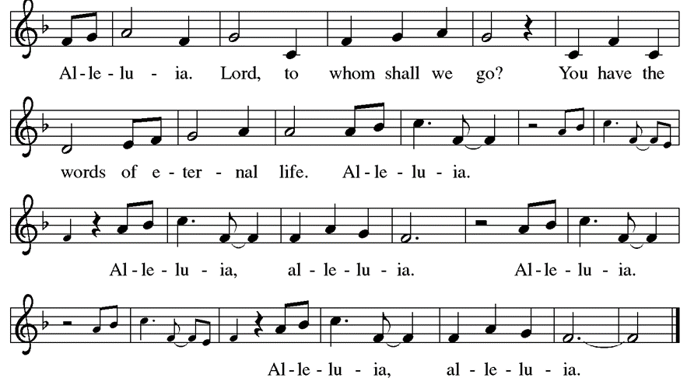

**Gospel Reading: Luke 16:1-13**

Jesus tells the curious story of a dishonest manager who cheats his employer and then is commended by him for having acted so shrewdly. Jesus wonders why his own followers are less creative and diligent in their stewardship given that they are managers of a far more valuable household.

P: The Holy Gospel According to Luke. **C: Glory to you, O Lord.**

P: 1 Then Jesus said to the disciples, “There was a rich man who had a manager, and charges were brought to him that this man was squandering his property. 2 So he summoned him and said to him, ‘What is this that I hear about you? Give me an accounting of your management because you cannot be my manager any longer.’ 3 Then the manager said to himself, ‘What will I do, now that my master is taking the position away from me? I am not strong enough to dig, and I am ashamed to beg. 4 I have decided what to do so that, when I am dismissed as manager, people may welcome me into their homes.’ 5 So, summoning his master’s debtors one by one, he asked the first, ‘How much do you owe my master?’ 6 He answered, ‘A hundred jugs of olive oil.’ He said to him, ‘Take your bill, sit down quickly, and make it fifty.’ 7 Then he asked another, ‘And how much do you owe?’ He replied, ‘A hundred containers of wheat.’ He said to him, ‘Take your bill and make it eighty.’ 8 And his master commended the dishonest manager because he had acted shrewdly, for the children of this age are more shrewd in dealing with their own generation than are the children of light. 9 And I tell you, make friends for yourselves by means of dishonest wealth so that when it is gone they may welcome you into the eternal homes.  
  10 “Whoever is faithful in a very little is faithful also in much, and whoever is dishonest in a very little is dishonest also in much. 11 If, then, you have not been faithful with the dishonest wealth, who will entrust to you the true riches? 12 And if you have not been faithful with what belongs to another, who will give you what is your own? 13 No slave can serve two masters, for a slave will either hate the one and love the other or be devoted to the one and despise the other. You cannot serve God and wealth.” P: The Gospel of the Lord. **C: Praise to you, O Christ.**

**Sermon** Rev. Jeremiah Smith

*P**lease stand as you are able.*

**Hymn of the Day: Rise Up, O Saints of God ELW #669**

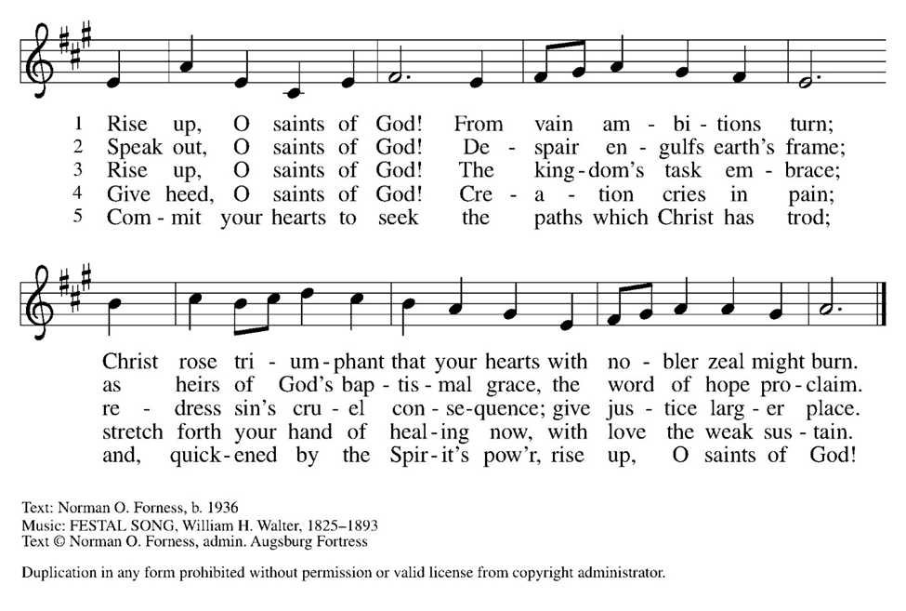

**Apostles Creed**

WA: Let us confess the faith using the words of the Apostles Creed.

**C:  I believe in God, the Father almighty, creator of heaven and earth.**

**I believe in Jesus Christ, God’s only Son, our Lord, who was conceived by the Holy Spirit, born of the virgin Mary, suffered under Pontius Pilate, was crucified, died, and was buried; he descended to the dead. On the third day he rose again; he ascended into heaven, he is seated at the right hand of the Father, and he will come to judge the living and the dead.**

**I believe in the Holy Spirit, the holy catholic church, the communion of saints, the forgiveness of sins, the resurrection of the body, and the life everlasting. Amen.**

**Prayers of the People**  
WA: Gracious God, we come to you in prayer for the church, the world, and all in need. *(a brief silence)*

WA: O God, teach your church to act in solidarity with the poor, frustrating the efforts of those who trample on the needy and practicing justice in our own life and community. God of grace, **C: receive our prayer.**

WA: Holy One, embolden elected leaders to pursue political policies of economic justice for the benefit of all, especially those who are most vulnerable and marginalized. Persuade them by your example of generosity and compassion. God of grace, **C: receive our prayer.**

WA: Compassionate God, we pray for all facing illness, those near death, or those grieving loved ones, especially those we name aloud or in the silence of our hearts…. May they find comfort and strength in your love. Prepare us to surround them with your healing care. God of grace, **C: receive our prayer.**

WA: God of love, motivate our congregation to enact economic justice through tangible action, prioritizing the needs of our community and sharing resources generously through our outreach and justice ministries. God of grace,

**C: receive our prayer.**

WA: Gracious God, we give thanks for the saints who now join the heavenly chorus in praising your name. Lift us up from the dust of grief and remind us of your promise of new life. God of grace, **C: receive our prayer.**

WA: We entrust these prayers to you, O God, in the name of Jesus Christ, our redeemer and friend. **C: Amen.**

**Peace**

P: The peace of Christ be with you always. **C: And also with you.**

**Meal**

*God feeds us with the presence of Jesus Christ*

**Offering** *Congregation may be seated*

We are grateful to those who help sustain our mission. To donate online, please use QR code:



**Offering Prayer**

WA: Let us pray together:

**C: Lord of the harvest, we return to you a portion of what you have given to us. Turn us to set our hope not on the uncertainty of riches, but on you, who richly provides for us. Multiply what we have gathered to bless all who ae suffering and in need, through Jesus Christ our Lord. Amen.**

*Please stand as you are able*

***+* Offertory Song “**Praise God From Whom….” *(doxology)*

ELW 885 (*music from ELW 883*)

***Praise God, from whom all blessings flow;***

***praise God, all creatures here below;***

***praise God above, ye heav’nly host;***

***praise Father, Son, and Holy Ghost. Amen.***

**GREAT THANKSGIVING**

P: The Lord be with you. **C: And also with you.**

P: Lift up your hearts. **C: We lift them to the Lord.**

P: Let us give thanks to the Lord our God.

**C: It is right to give our thanks and praise.**

**Preface:**

P: It is indeed right, our duty and our joy, that we should at all times and in all places give thanks and praise to you, almighty and merciful God, through our Savior Jesus Christ; who on this day overcame death and the grave, and by his glorious resurrection opened to us the way of everlasting life. And so, with all the choirs of angels, with the church on earth and the host of heaven, we praise your name and join their unending hymn:

**Holy Holy Holy ELw** setting 8

*(printed next page)*

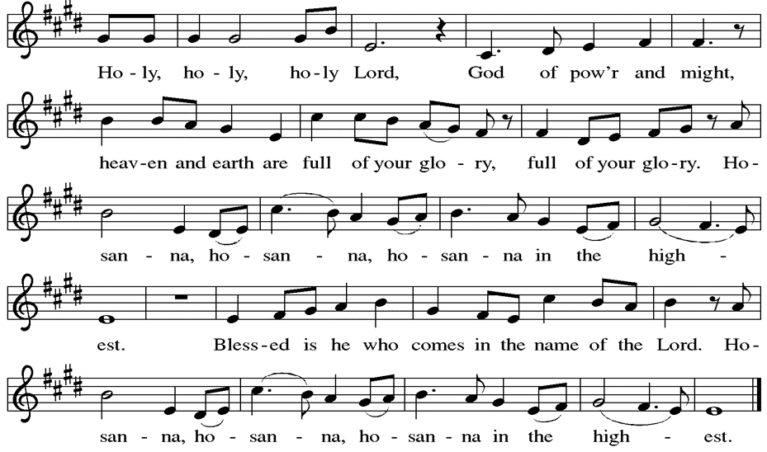

**Thanksgiving at the Table**

P: In the night in which he was betrayed, our Lord Jesus took bread, and gave thanks; broke it, and gave it to his disciples, saying: Take and eat; this is my body, given for you. Do this for the remembrance of me. Again, after supper, he took the cup, gave thanks, and gave it for all to drink, saying: This cup is the new covenant in my blood, shed for you and for all people for the forgiveness of sin. Do this for the remembrance of me.

**Lord’s Prayer**

P:Lord, remember us in your kingdom and teach us to pray.

**C: Our Father, who art in heaven, hallowed be thy name, thy kingdom come, thy will be done, on earth as it is in heaven. Give us this day our daily bread; and forgive us our trespasses, as we forgive those who trespass against us; and lead us not into temptation, but deliver us from evil. For thine is the kingdom, and the power, and the glory, forever and ever. Amen.**

**Invitation to the Table**

*At Parkside Lutheran Church we have an open table. We believe the invitation to receive comes from Jesus himself and all are welcome at Christ’s table. More than just Bread and Wine these are tangible signs of God’s love for you! If you do not wish to receive communion but would like a blessing, come forward and cross your arms over your chest. The Pastor will give you a blessing before you return to your seat via the side aisle. You’ll receive communion bread* in your hands and a small cup containing white wine or grape juice. When giving the bread and cup, the communion ministers say:*

*“*The body of Christ, given for you. The blood of Christ, shed for you.” *and each person may respond :* Amen *Please let Pastor know if you need gluten-free bread

P: Jesus welcomes sinners and eats with them. Come to this meal of mercy.

**The Communion Distribution**

**Communion Song** ELWsetting 8

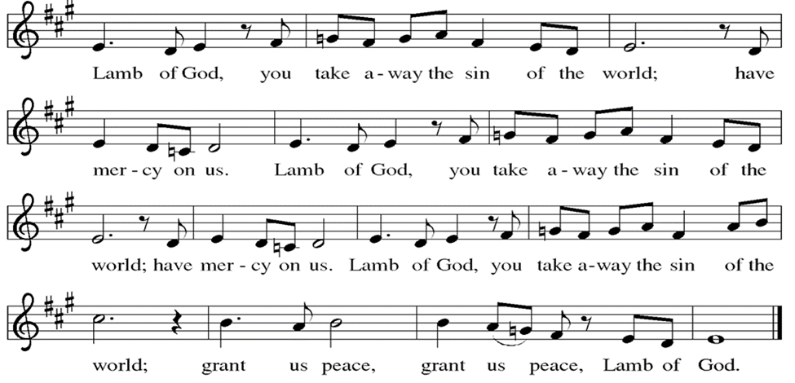

**Communion Song: Sanctuary**

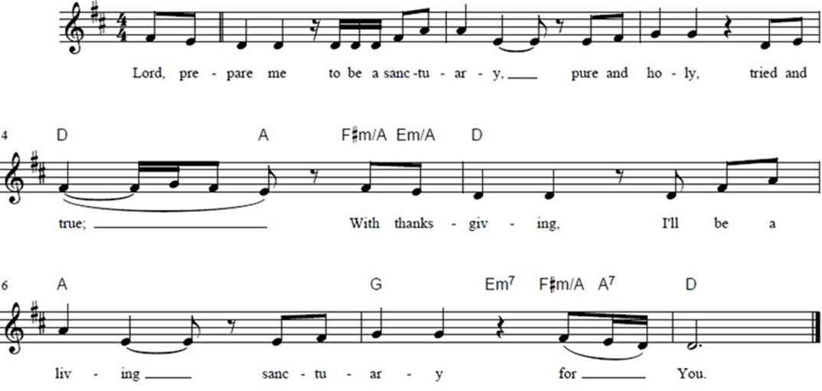

**Post Communion Blessing**

P: The Body and Blood of our Lord and Savior, Jesus Christ, strengthen you and keep you in God's grace. **C: Amen.**

**Prayer After Communion**

WA: Let us pray together.

**C: O God, through this meal you have strengthened us and appointed us to be your servants. Send us to do good and to share our possessions with all in need. We ask this in Jesus’ name. Amen.**

**Sending -** *God blesses us and sends us in mission to the world.*

**Blessing**

P: The God of righteousness, who gives justice to the oppressed, who gives food to the hungry, who sets the prisoners free, ☩bless you now and forever. **C: Amen.**

**Sending Hymn: Let Streams of Living Justice ELW #710**

*(printed next page)*

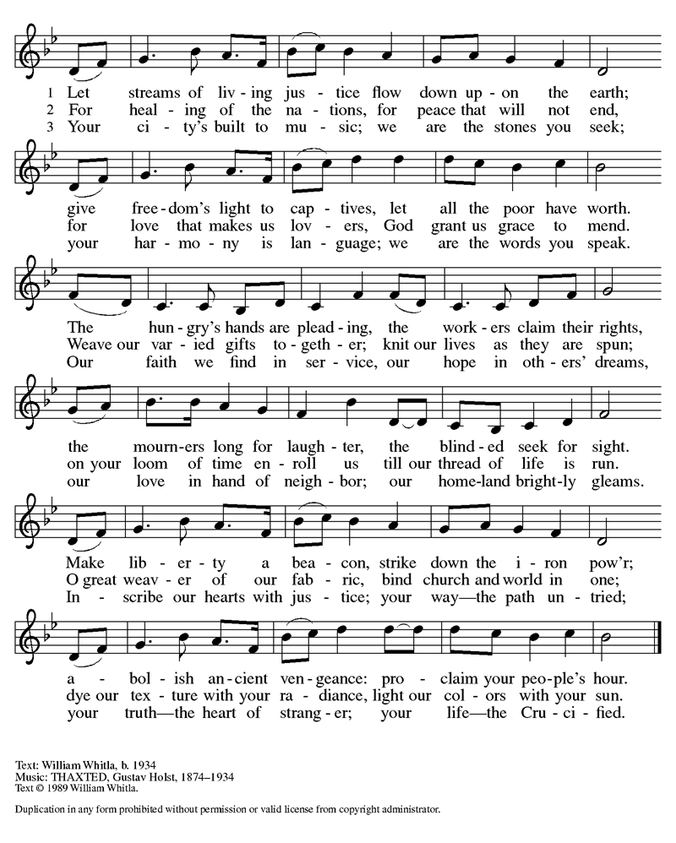

**Dismissal and Postlude**

WA: Parkside Lutheran Church is rediscovering the radical love of Jesus.

**C: Gathering All. Serving All. Caring for All.**

WA: Go in peace. Do not lose heart.

**C: Thanks be to God.**

*ELW Music licensed from Sundays & Seasons, Augsburg Fortress CCLI MUSIC License # 11440069 , CCLI*

*Streaming License#21835523 Do not duplicate any music or Liturgy herein without license and permission*

*To sponsor Altar flowers or a Soloist in honor of a loved one*

*or to mark a special occasion. Contact the office for more info.*

**PARKSIDE STAFF:**

• The Rev.  Jeremiah Smith: prjeremiahpsmith@gmail.com

• Kris Pope & Suzanne Gracie, Admin. Assistants (Church Office): parksidelutheran@gmail.com

• Mike Hooker, Music Director: [mrhooker@me.com](mailto:mrhooker@me.com)

CHURCH OFFICE HOURS: M/T/R 10:00am-3:00pm   (716)836-1361

**SCHEDULES and Events:**

|  |  |  |
| --- | --- | --- |
| Acolytes: |  | Worship Assistants |
| 9/21 – Chris & Katie |  | 9/21 – Susan |
| 9/28 – David & Grace |  | 9/28 - Vince |
| Readers: |  | Ushers: |
| 9/21 – Sarah |  | 9/21 – John V & Zack R |
| 9/28 - Susan |  | 9/28 –David H & Sue S |

**Coming up:** *contact office for more info –* [*parksidelutheran@gmail.com*](mailto:parksidelutheran@gmail.com), *(716)836-1361*

* September 28th – New Usher Training, after Worship
* September 28th – Burrito Project Meeting, after Worship
* ***September 28th – Last Day for Harvest House Baby Shower Donations***
* October 4th – Altar Guild Cleaning Day 9:30am – 12pm
* October 5th & 19th – Intergenerational First Communion Classes, after Worship
* ***October 17th –*** ***Meat Raffle – VOLUNTEERS NEEDED!*** Contact Kristen Lenz if you are able to volunteer, donate a raffle item, sponsor a meat round, or buy a table [kristenlenz@gmail.com](mailto:kristenlenz@gmail.com)
* October 25th – Halloween Event 4pm
* October 26th – First Communion

Detailed announcements and more are found in the e-newsletter. Sign up for e-newsletter on our website parksidelutheran.org or via constant contact with the QR code. You can find the full bulletin in the Worship section of our website www.parksidelutheran.org.